There are no people around to ask but our model guarantees that the Covid-19 London soundscape is drab. It’s not that bad in parks, though. And yes, we’ve built a cool model.

Modeling Lockdown Soundscape

Tin Oberman,1 Andrew Mitchell,1 Magdalena Kachlicka,1 Francesco Aletta,1 Matteo Lionello,1 Mercede Erfanianan1 and Jian Kang1, [1]a

1 Institute for Environmental Design and Engineering, the Bartlett, University College London, London, United Kingdom

This paper is part of a special issue on COVID-19 Pandemic Acoustic Effects.

The unprecedented lockdown enforced by governments around the world to fight the Covid-19 pandemic in the first half of 2020 triggered a change in human activities taking place in public spaces and acoustic environment in cities. This study was conducted to characterize this change as it would potentially be perceived by people. As people were not present in the observed public spaces to be surveyed, the predictive model ‘in-development’ for the purpose of the ERC-funded research project Soundscape Indices (SSID) was used. Thanks to the work conducted within the scope of the SSID project 2019, we were able to observe identical locations during spring 2020. The lockdown condition allowed testing of the model using a range of conditions from the same location and the time of day, unobtainable in any other way. Approx. 30-second-long binaural recordings during 1-3 hrs, mimicking typical experience of a passer-by, were performed at 13 public spaces across London (N=11) and Venice (N=2). Mixed-effects (multi-level) linear regression models were built based on the database created during the on-site surveys in 2019. These predictive models underwent a comprehensive feature selection process starting with an initial set of 119 psychoacoustic features. The models were focused on predicting the perceived dominance of natural sounds and overall soundscape quality. A series of Kruskal-Wallis tests were performed to look into the significance of the change between the normal (2019) and the predicted perceived lockdown condition. Validation of the model was performed via ‘user-calibrated’ binaural listening tests distributed on-line. Validation showed … Results indicate: 1) general background level drop of xx dBA, 2) general change in sound events L5 of zz dBA, 3) general drop of loudness of yy across the locations, 4) natural sounds perceived more dominant at ZZ locations, 5) overall soundscape quality perceived worse at ZYS locations and better at YZX locations. The observed change in acoustic measures and perceived dominance of natural sound sources was smaller in parks / locations characterized by high presence of natural sounds in 2019. The framework tested in this study has the potential for use in soundscape quality assessment of locations hard to survey. The study indicated the importance human activity has for the overall soundscape quality of public spaces.

100 words for Letters to the Editor.

1. INTRODUCTION

A paragraph on importance of soundscape, its dependency on sound sources and the effect of human activity on soundscape. How does human activity influence background levels and soundscape perception?

This study was enabled by the framework of the ERC-funded project Soundscape Indices (Kang et al. 2019) focused on soundscape assessment of public spaces and a protocol defined for that purpose (Mitchell et al. 2020). During 2019 a number of public spaces was surveyed using the protocol, focusing on characterizing individual human experience of urban environment. During April 2020, the protocol was partially repeated across the same eleven locations in London and two locations in Venice to characterize the effect of the unprecedented lockdown.

A paragraph on the news coverage of the change in the acoustic environment of cities during the lockdown, birdsong, Google data on increased usage of parks and similar.

A paragraph advocating how soundscape approach is the right way to analyze the change caused by the lockdowns everybody is talking about, the need to develop soundscape index and overcome the use of dB scales in soundscape planning (Kang et al. 2019). Acoustic and non-auditory indicators.

Francesco would write A paragraph or two about (linear regression) soundscape modelling (Aletta, Kang, and Axelsson 2016). Soundscape assessment requires people to be surveyed but presence of people at a locations influences assessment (Aletta and Kang 2018) and ‘quiet places’ require low number of users to remain quiet, which limits the possibility of assessment. Moreover, even in crowded public space, soundscape studies are demanding as they require significant man power and time (Mitchell et al. 2020). Therefore, a need for a predictive model arises to overcome this limitation.

A paragraph featuring clear RQs addressing the differences before and after lockdown – 1) the effects of human activities on acoustic environment, and 2) modelling how would people perceive the changed in the acoustic environment.

1. MATERIALS AND METHODS

A paragraph or two on the description of the whole framework: protocol + building a model / running the model on lockdown data + validation.

A paragraph with the Figure 1 callout sentence.

FIG. 1. Methodological framework of the study

1. Data collection / Recording phase

Half page on Binaural recordings as per (Mitchell et al. 2020) (Equipment and procedure) and half page of location description per ISO/TS 12913-2:2018 (International Organisation for Standardization 2018) (notes about sound sources and typical use of each location).

TABLE I. with pictures 2019 vs 2020, Google Maps and panoramas taken by researchers (one per year instead one per SessionID, probably a table taking a whole page)

|  |  |  |
| --- | --- | --- |
|  | Satelite Picture | Panoramic picture |
| SanMarco 2019 |  |  |
| San Marco 2020 |  |  |
| Camden Town 2019 |  |  |
| Camden Town 2020 |  |  |
| Torrington Square 2019 |  |  |
| Torrington Square 2020 |  |  |

1. Modelling phase

Andrew would write Description of the model – why it was built per location, how the focus on Natural and Overall was selected. Key features.

*Structure / type of model -> relate to type of output variable.*

The inherent structure of the SSID database necessitates a modelling and analysis approach which considers the differing relationships between the objective acoustic features and the soundscape’s perceived affective quality ratings across the various locations and contexts. Therefore separate linear mixed-effects models (LMMs) were computed in order to predict the assessed soundscape pleasantness and eventfulness, and the rated presence of natural sounds, human sounds, and traffic noise. The fixed effects level of the models is made up of the acoustic features calculated from the binaural recordings made during each respondent’s survey period, while the random effects level includes the categorical variable indicating the location in which the survey was taken.

Multi-level models are commonly employed in both environmental and social sciences

*Description of split into training and test sets*

*Model building*

Two procedures were used for training the OLR model(s), under the assumption that Location-level differences may play a significant role in increasing prediction accuracy. In one case, the training dataset was divided according to the location, and a separate model was trained on each location’s data individually, resulting in a set ??11 models, one for each location. This model was then applied to the testing dataset for only the appropriate location, and the results were combined and compared to assess the overall prediction accuracy.

In the second case, the training set was left intact, and a single model was trained covering all locations. This model was then applied to the testing set and assessed for prediction accuracy. The first method produced a prediction accuracy of ??50% while the second resulted in a prediction accuracy of ??50%. Given the 11-fold increase in complexity, and the limited improvement in prediction accuracy, the first method of producing a model tailored to each location individually was abandoned, and for each output variable (i.e. for predicting Natural-sound dominance and overall soundscape quality) only one model describing the full training data set was constructed.

A paragraph with the Fig. 2. callout sentence.

FIG. 2. Graphical representation of the model

1. Validation phase

Magdalena would write a description of the listening tests with headphones – procedure – calibration tricks – stimuli selection and matrix (number of participants vs number of stimuli) – focus group – questionnaire in the appendix.

A paragraph with the Fig. 3. callout sentence.

FIG. 3. Experiment flow diagram

1. RESULTS
2. Acoustic environment before and during the lockdown

Results showing acoustic data for binaural recordings as box plots per location (normal condition and lockdown condition), clearly illustrating the range of data available by the lockdown, i.e. lowest levels recorded.

A paragraph describing trends observed in median, extreme values and ranges across the locations.

A paragraph on generalizing the data for whole of London/Venice or LocationID if the city would be too far-fetched (general drop in background, change in spectrum).

A paragraph with the Fig. 4. callout sentence.

FIG. 4. Boxplots of the key acoustic features

1. Lockdown Soundscape Prediction Compared to the 2019 Condition

Andrew will provide graphs.

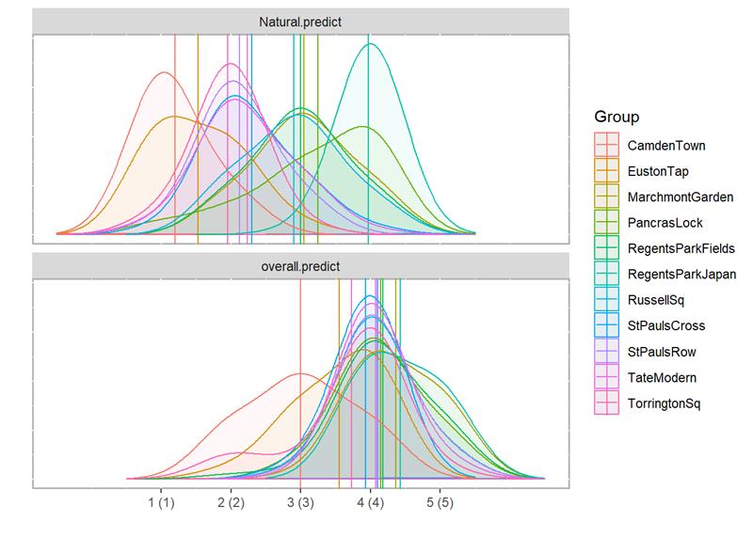

FIG. 5. Perceived dominance of natural sound sources (left) and Overall soundscape quality (right)

1. Validation _ Survey Results Compared to the Model

Magdalena will provide numbers, focused on immediate comparison with Andrew’s results.

1. DISCUSSION

Key features identified while modelling, key for the further development of the ISO 12913 series and soundscape indices.

Limitations of the study are few as we took care of everything, one paragraph about the limitations of the sampling method. Andrew would write another paragraph on the limitations of the modelling approach used.

Application of the model – soundscape assessment of locations where there are not enough people to survey, eventually being capable of predicting soundscape based on objective metrics.

Different effect of the lockdown per location type, no data on residential areas.

1. CONCLUSION

And in conclusion RQs andwered.

ACKNOWLEDGEMENTS

This project has received funding from the European Research Council (ERC) under the European Union’s Horizon 2020 research and innovation programme (Grant Agreement No. 740696, project title: Soundscape Indices – SSID). More information and related publications can be found at the CORDIS webpage of the project: https://cordis.europa.eu/project/rcn/211802/factsheet/en.

Authors would like to thank Zhongzhe Li for conducting binaural recordings at Euston Station and Torrington Square in autumn 2019.

Authors would like to thank Meihui, Nicolas Assiotis, Veronica Rugeles Allan, Yu Wang and Hua Su for their help in conducting on-site surveys during the spring and the autumn of 2019.

Study data were collected and managed using REDCap electronic data capture tools hosted at University College London (UCL).

REFERENCES

Aletta, Francesco, and Jian Kang. 2018. ‘Towards an Urban Vibrancy Model: A Soundscape Approach’. International Journal of Environmental Research and Public Health 15 (8): 1712. https://doi.org/10.3390/ijerph15081712.

Aletta, Francesco, Jian Kang, and Östen Axelsson. 2016. ‘Soundscape Descriptors and a Conceptual Framework for Developing Predictive Soundscape Models’. Landscape and Urban Planning 149 (May): 65–74. https://doi.org/10.1016/j.landurbplan.2016.02.001.

International Organisation for Standardization. 2018. ‘ISO/TS 12913-2:2018 Acoustics — Soundscape — Part 2: Data Collection and Reporting Requirements’. https://www.iso.org/standard/75267.html.

Kang, Jian, Francesco Aletta, Tin Oberman, Mercede Erfanian, Magdalena Kachlicka, Matteo Lionello, and Andrew Mitchell. 2019. ‘Towards Soundscape Indices’. In PROCEEDINGS of the 23rd International Congress on Acoustics, 2488–95. Aachen (DE): EAA, ICA, DEGA. http://pub.dega-akustik.de/ICA2019/data/articles/000560.pdf.

Mitchell, Andrew, Tin Oberman, Francesco Aletta, Mercede Erfanian, Magdalena Kachlicka, Matteo Lionello, and Jian Kang. 2020. ‘The Soundscape Indices (SSID) Protocol: A Method for Urban Soundscape Surveys—Questionnaires with Acoustical and Contextual Information’. Applied Sciences 10 (7): 2397. https://doi.org/10.3390/app10072397.

1. a [j.kang@ucl.ac.uk](mailto:j.kang@ucl.ac.uk)